**UAS Pemrograman**

Nama : Resa Rianti

NPM : 1204053

Prodi : D4 TI / 1B

Tema : Aplikasi Pendaftaran Pendaftaran Lomba AI (artificial intelligence)

**Tampilan Halaman Awal**



**Kodingan Halaman** awal_view

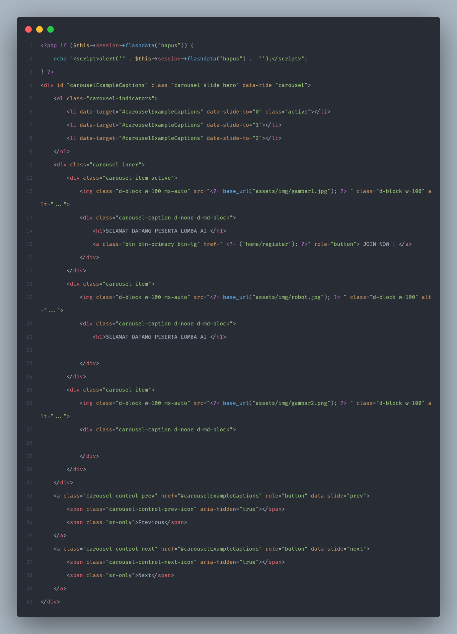

**Halaman awal : Controllers/Home.php**

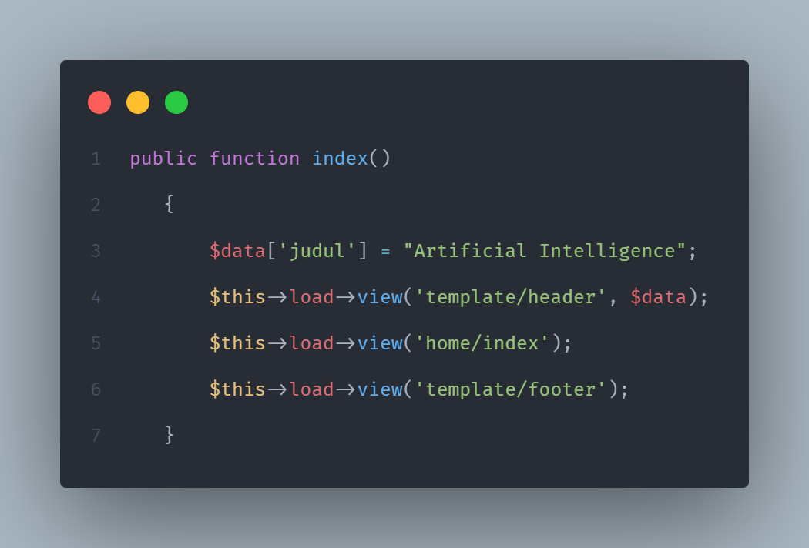

**template_footer**

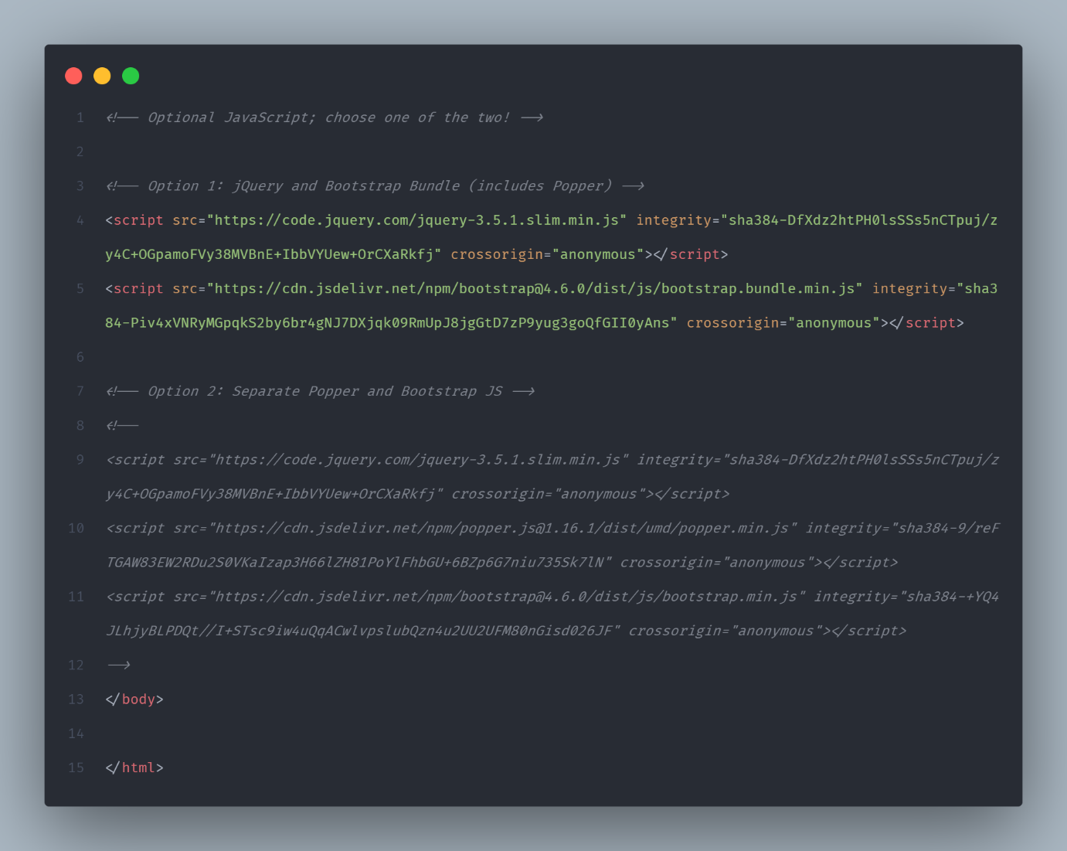

**template_header**

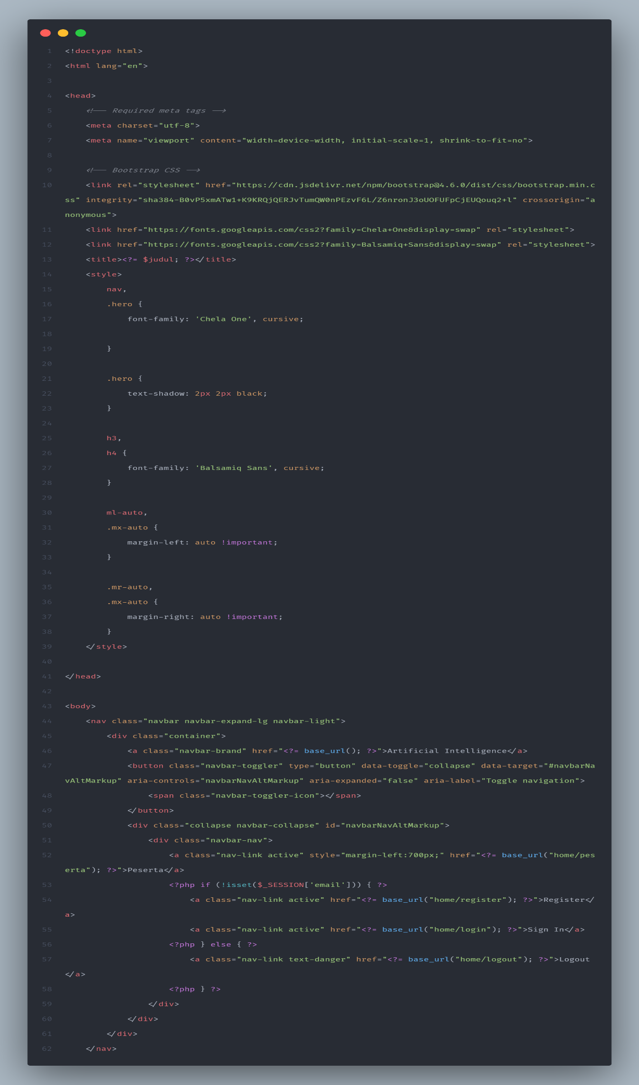

**Tampilan Halaman Register**

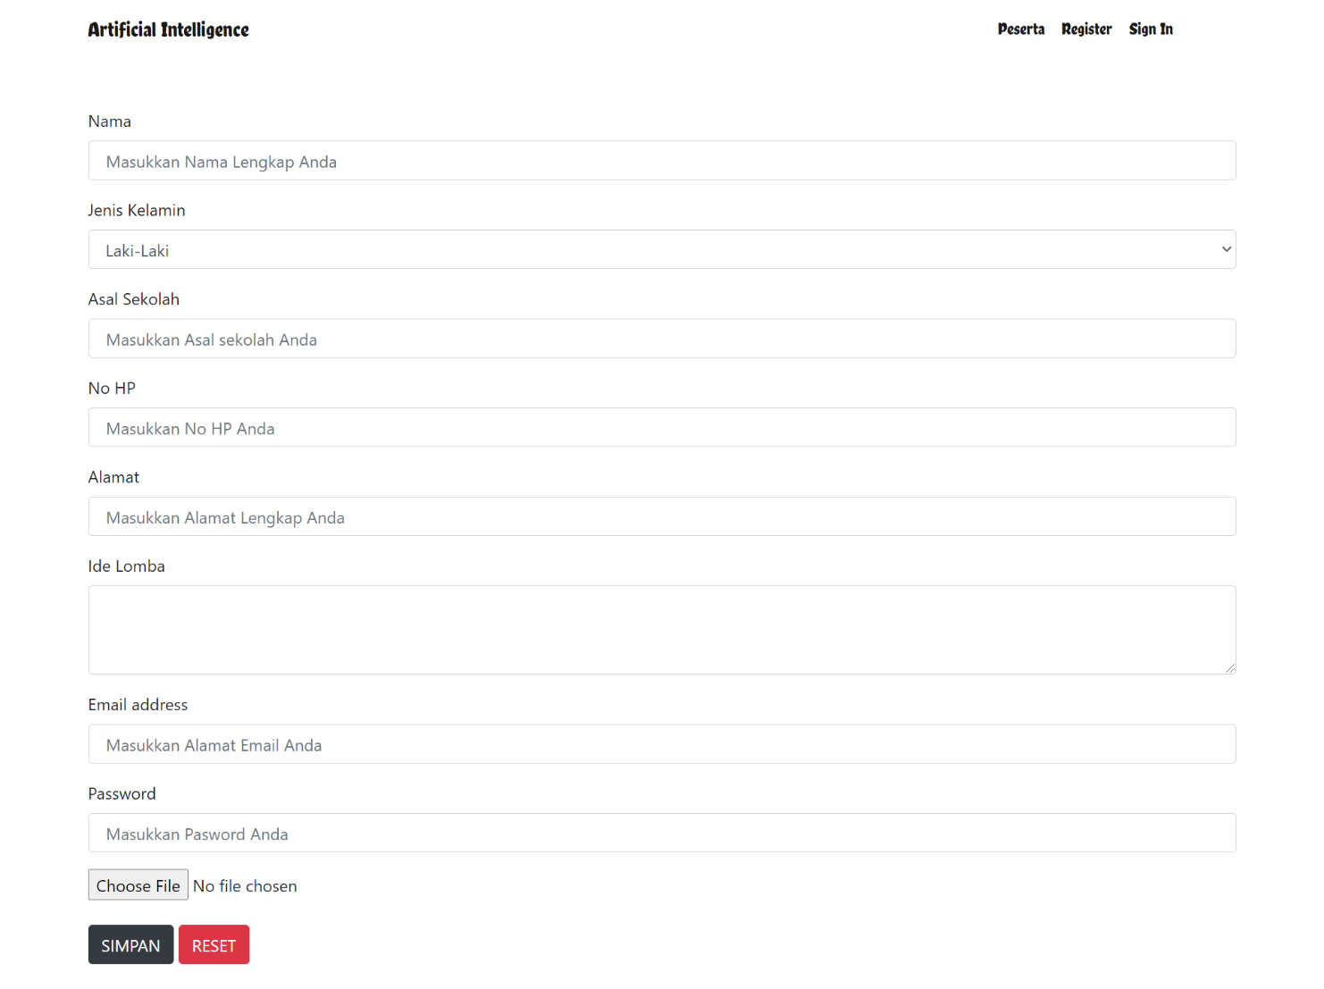

**Kodingan Controllers/registe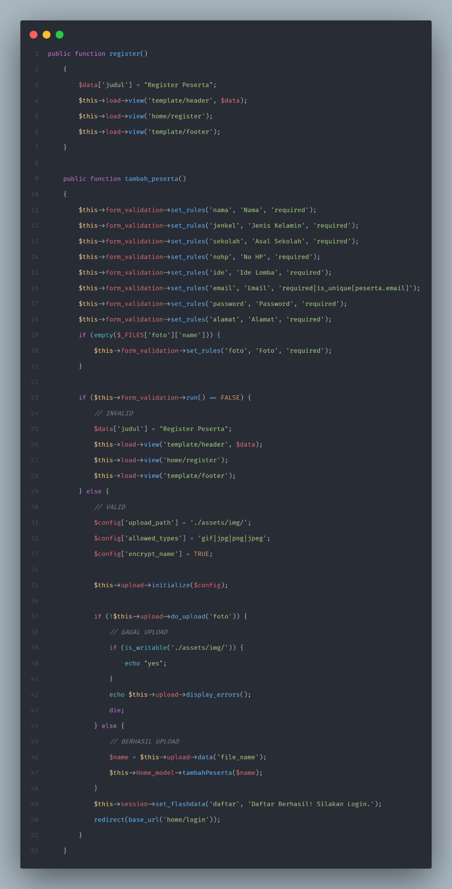r**

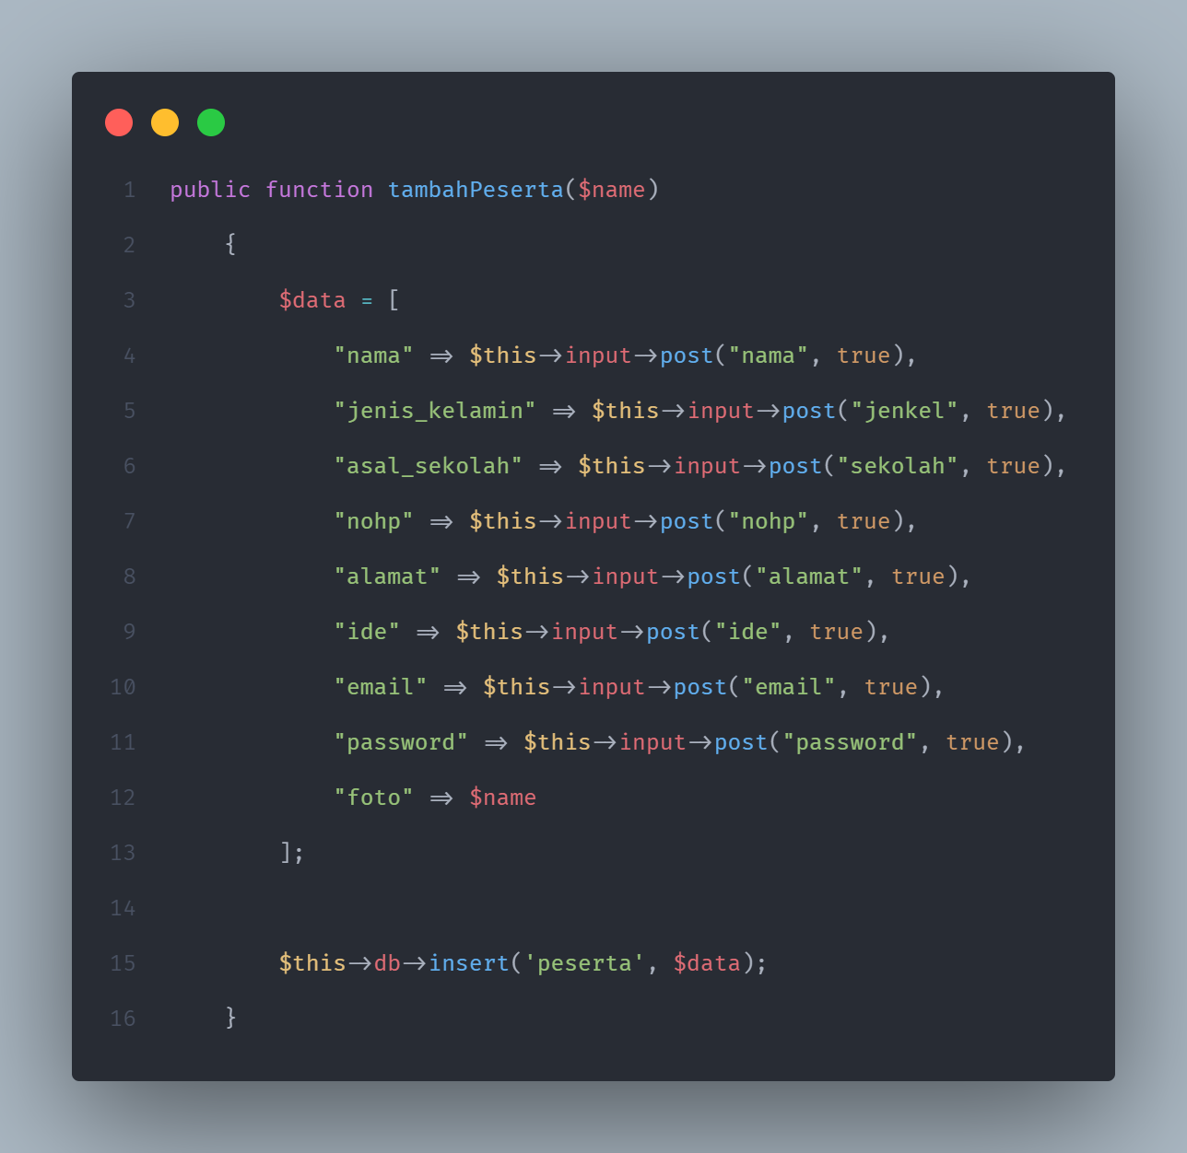**Kodingan models /register**

**Kodingan views/home/register.php**

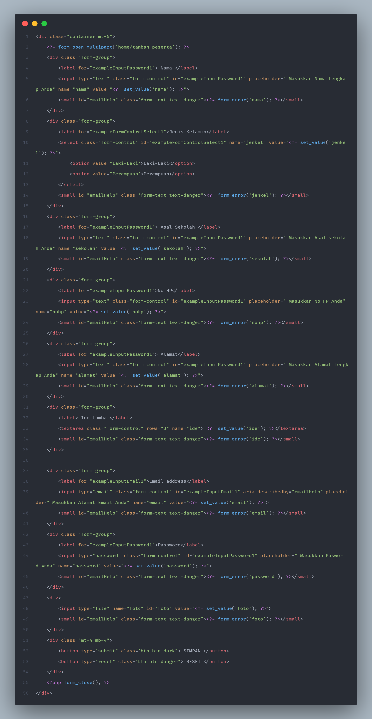

**Tampilan Halaman Login**

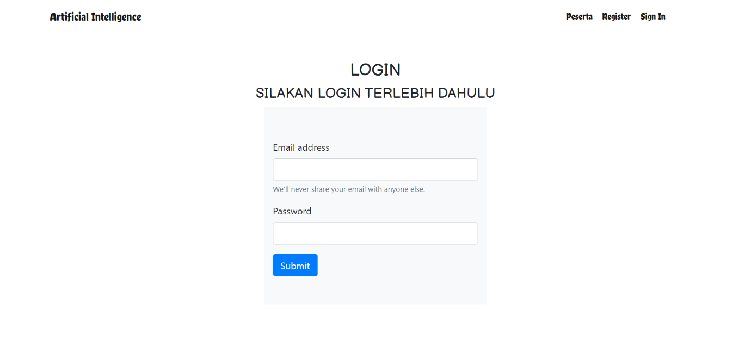

**Kodingan model/login**

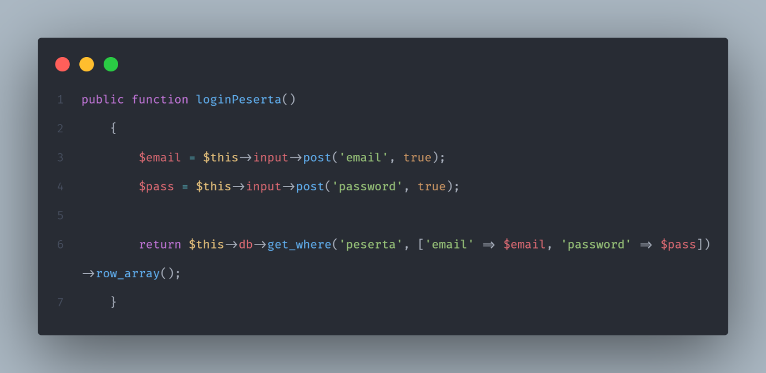

**Kodingan Controllers/Login**

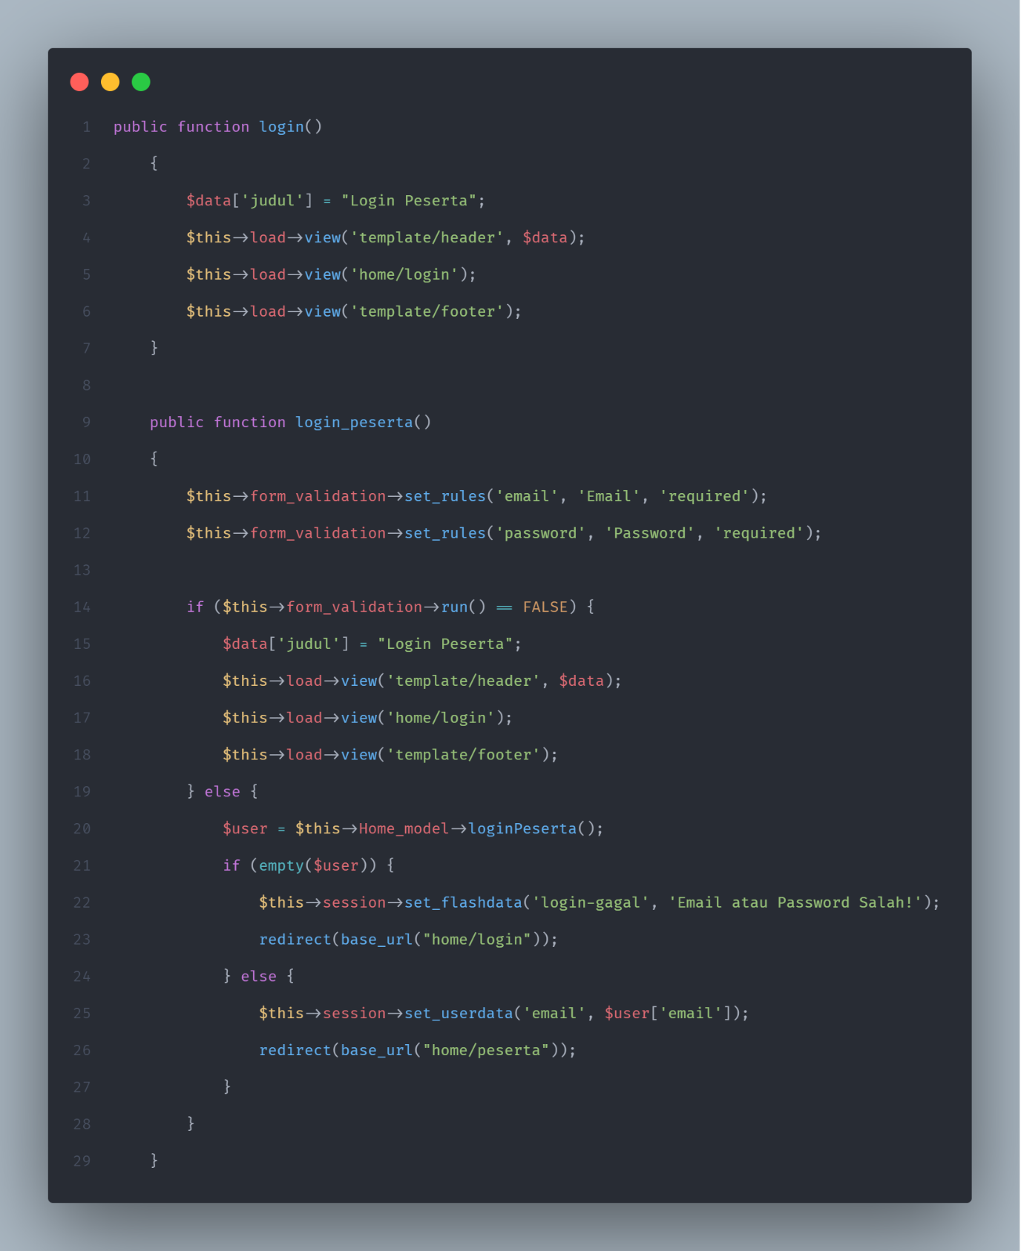

**Kodingan views/home/login.php**

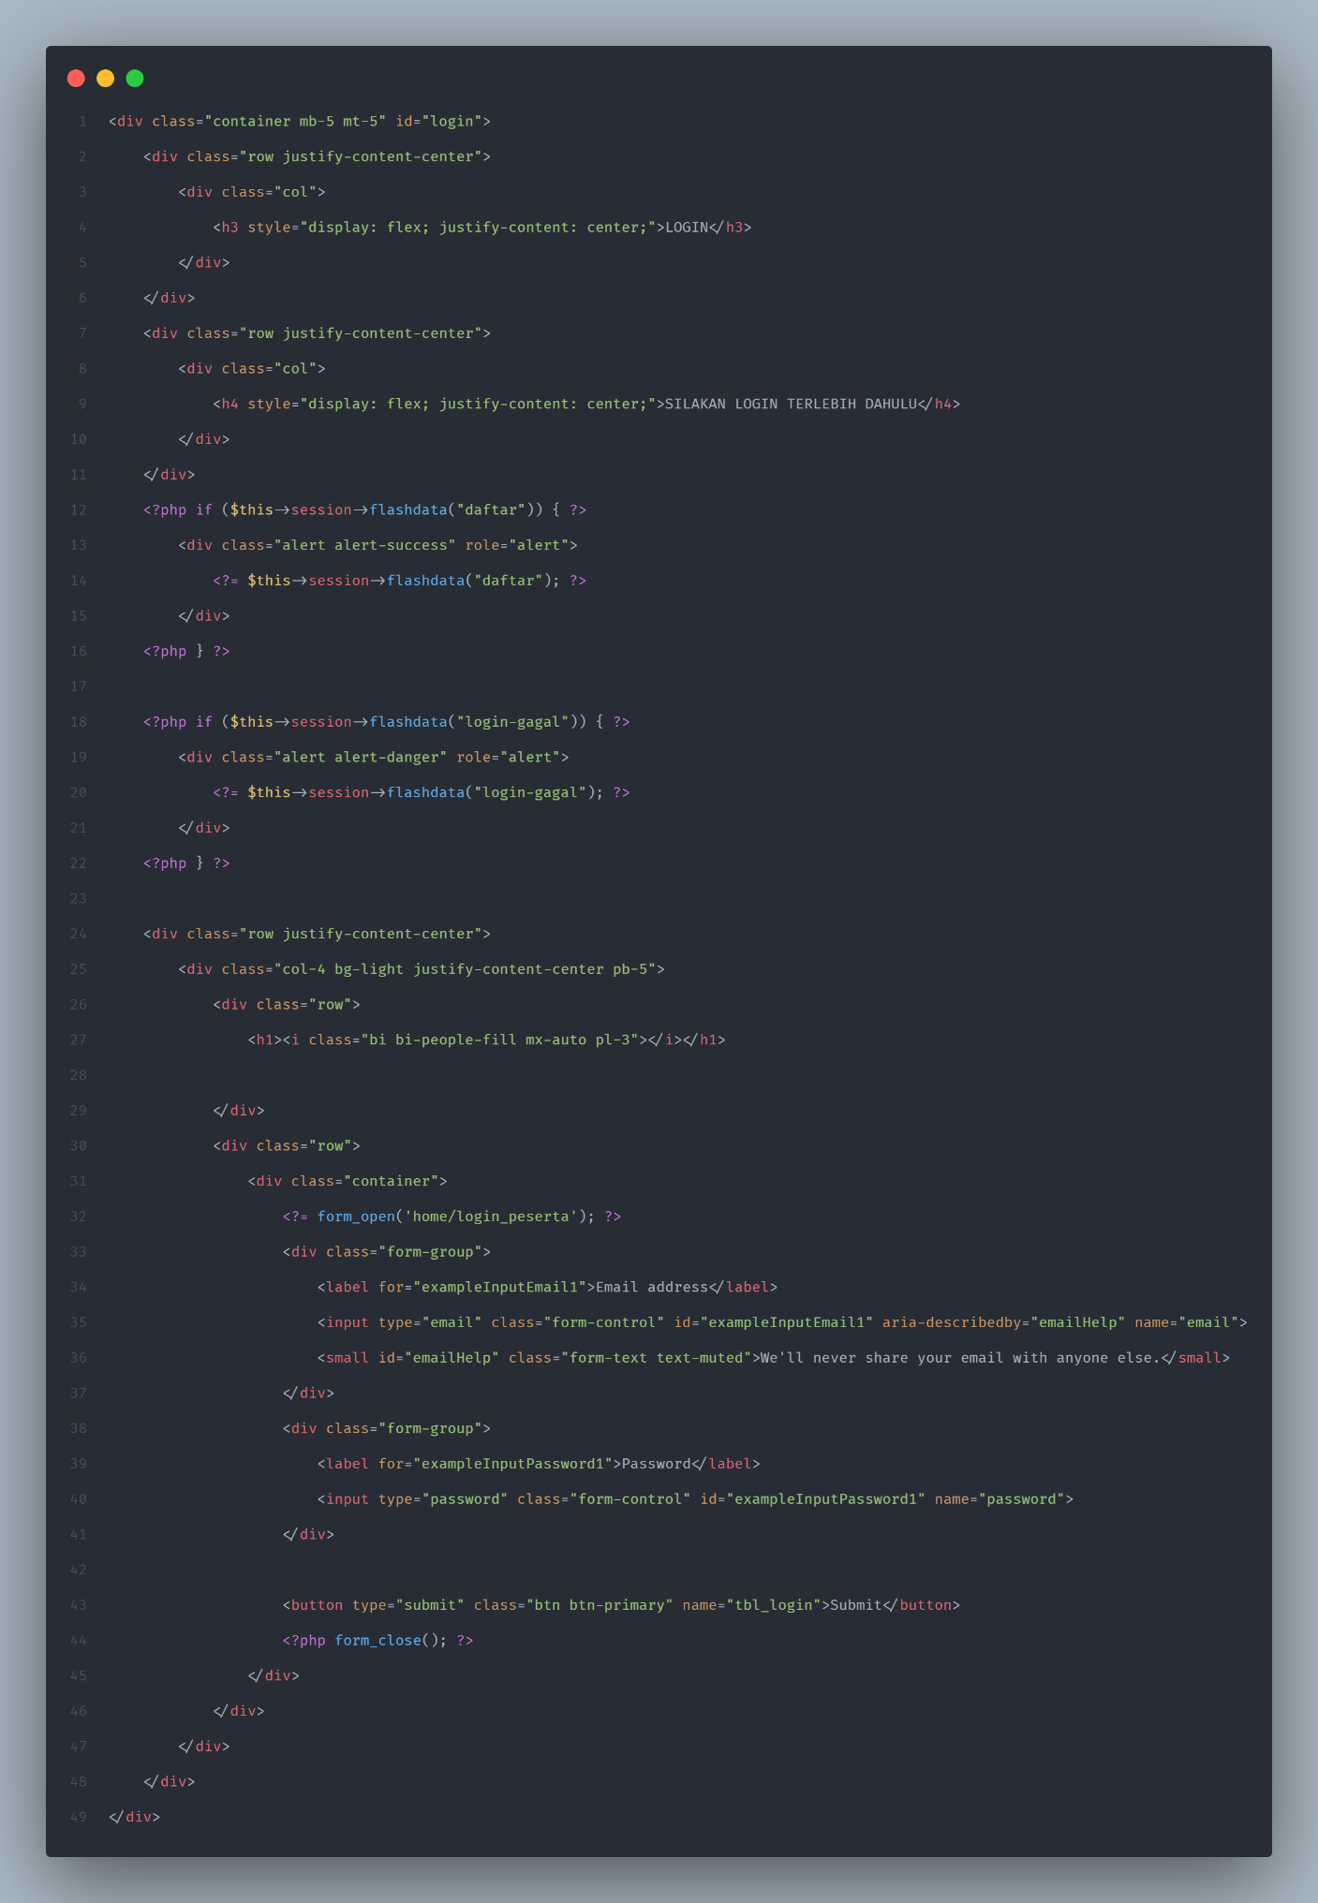

**Tampilan Halaman 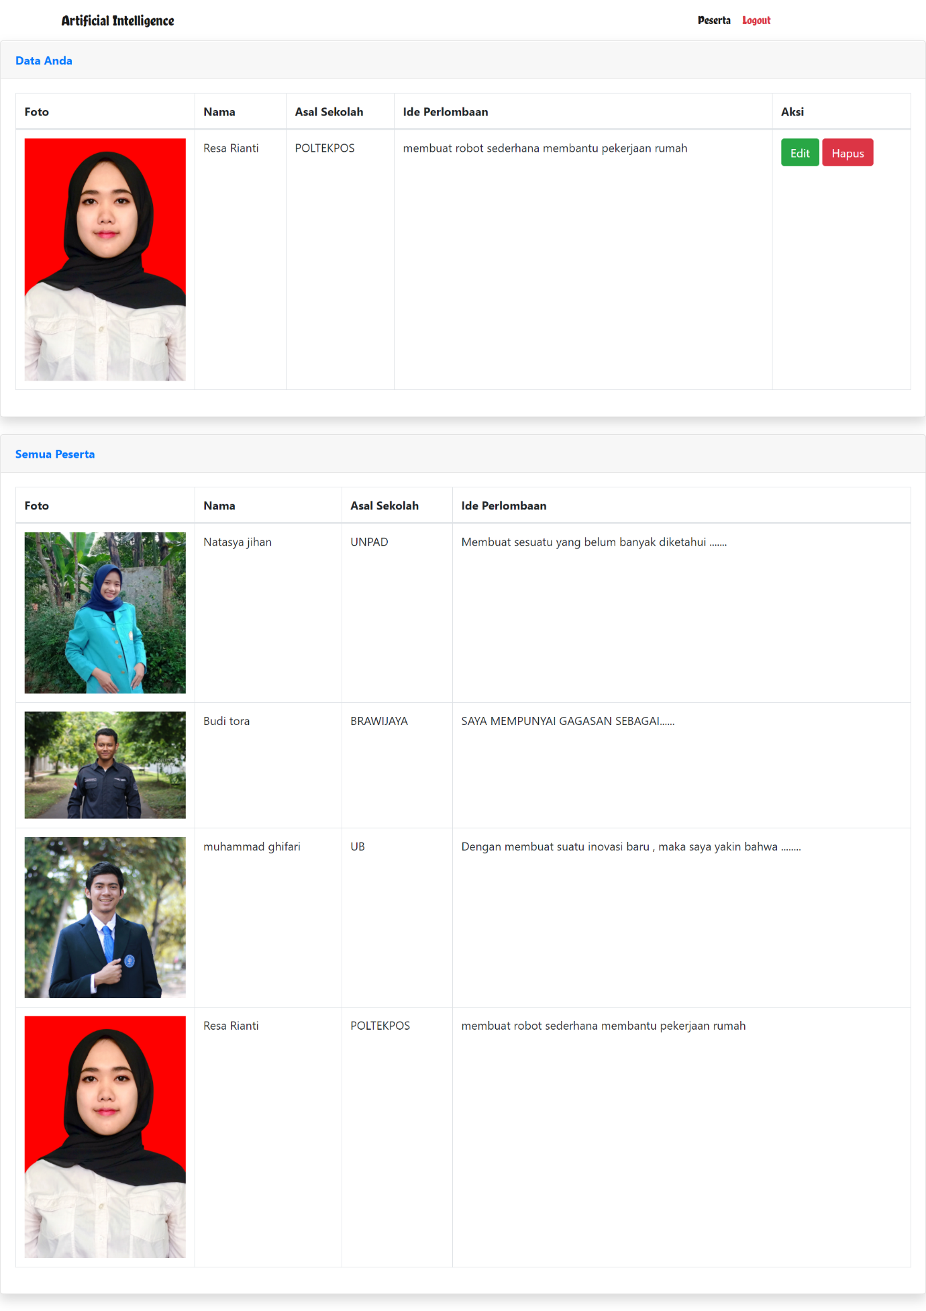Peserta**

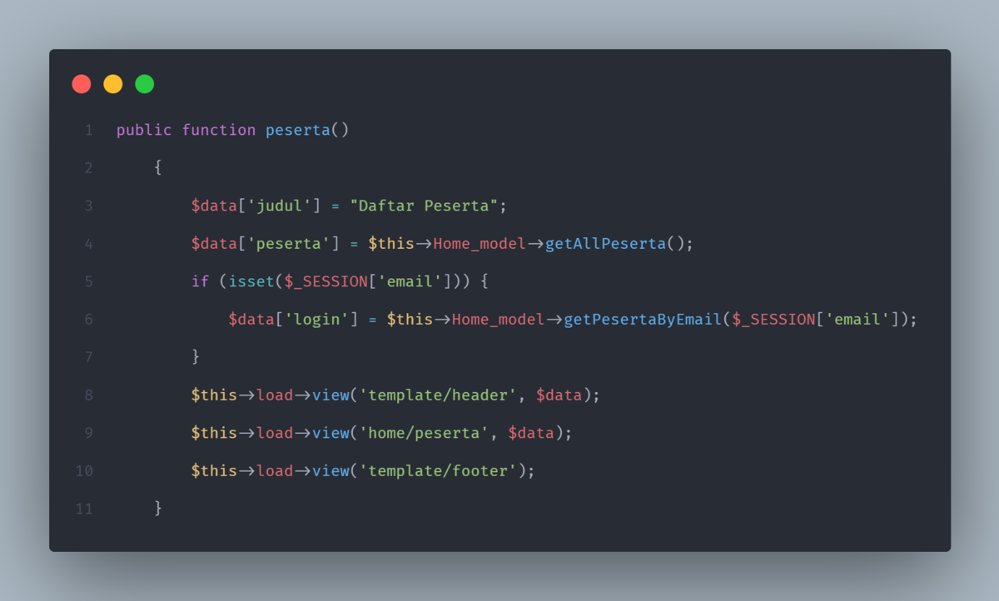**Kodingan Controllers/Peserta**

**Kodingan Models/Peserta**

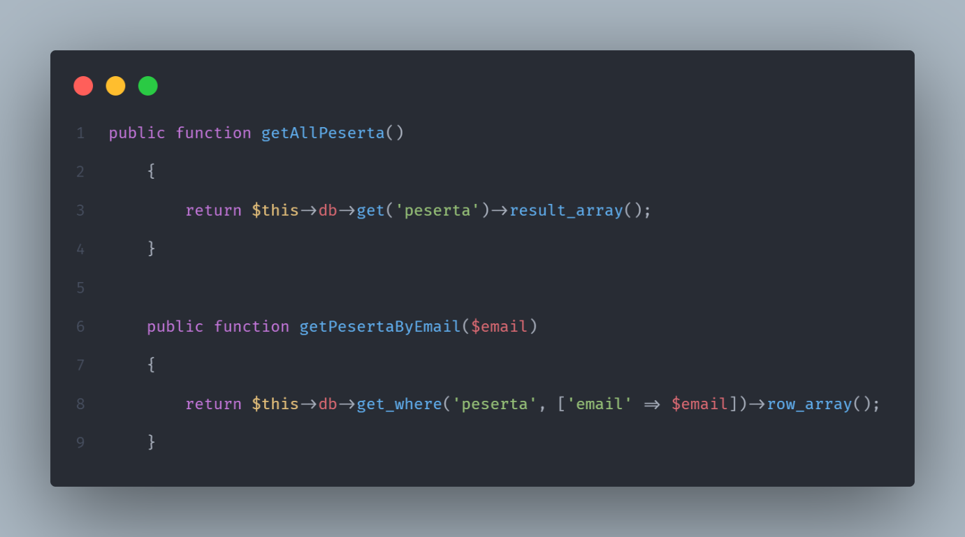

**Kodingan views/home/peserta.php**

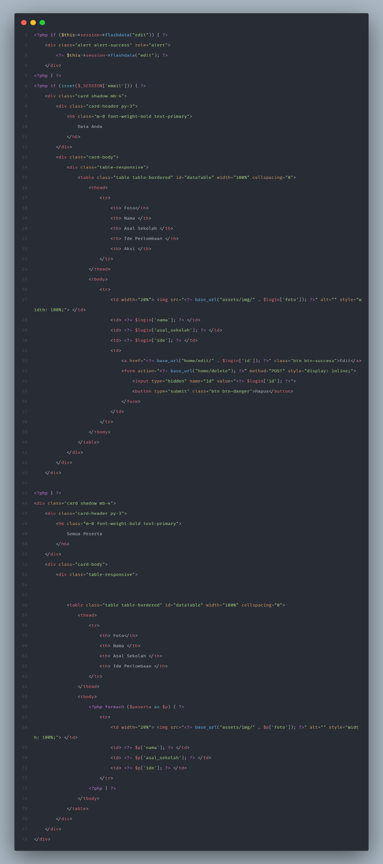

**Tampilan Halaman edit peserta**

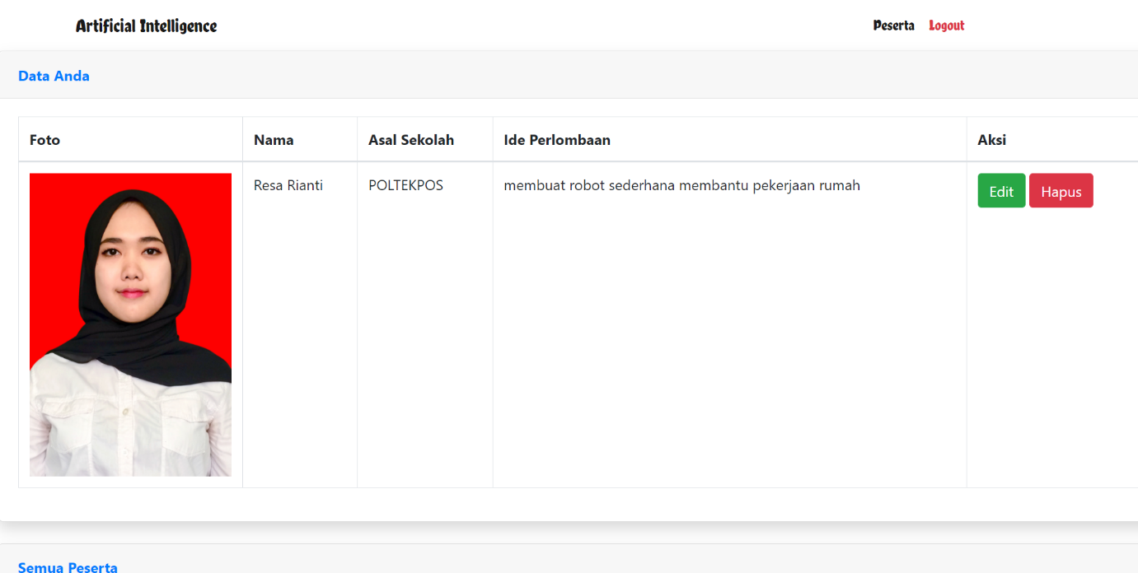

**Kodingan Controllers/edit peserta**

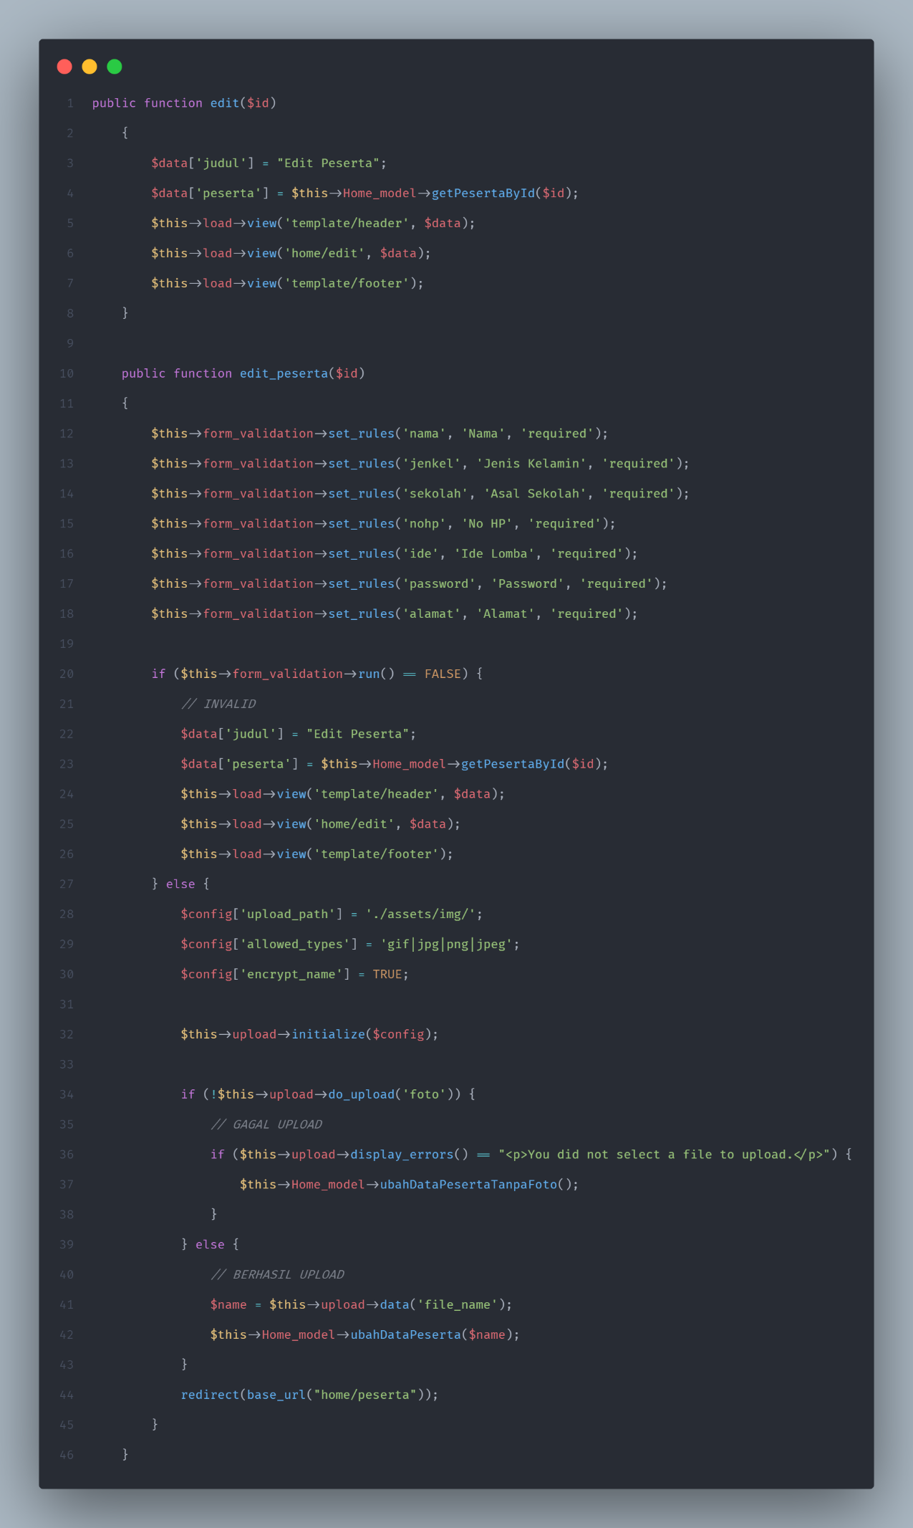

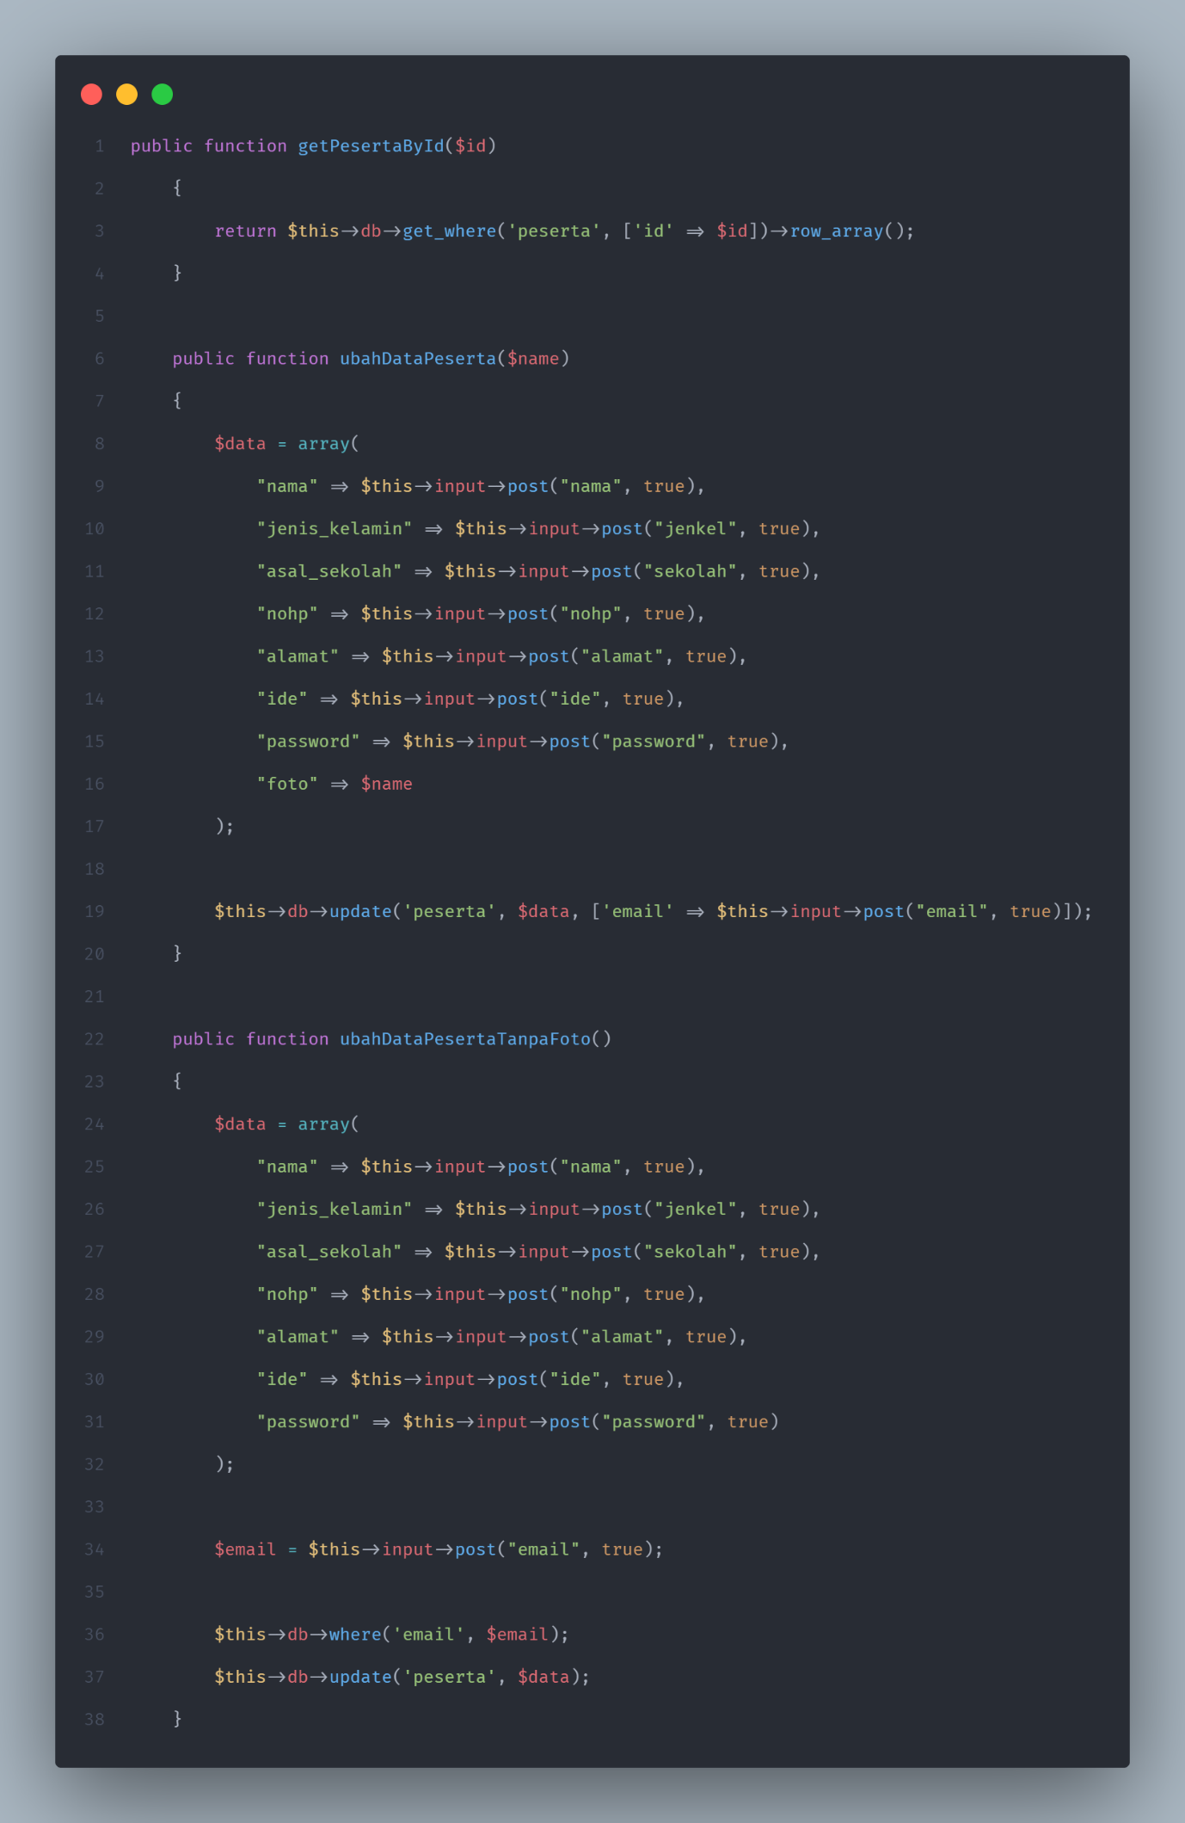**Kodingan Models/edit Peserta**

**Kodingan views/home/edit.php**

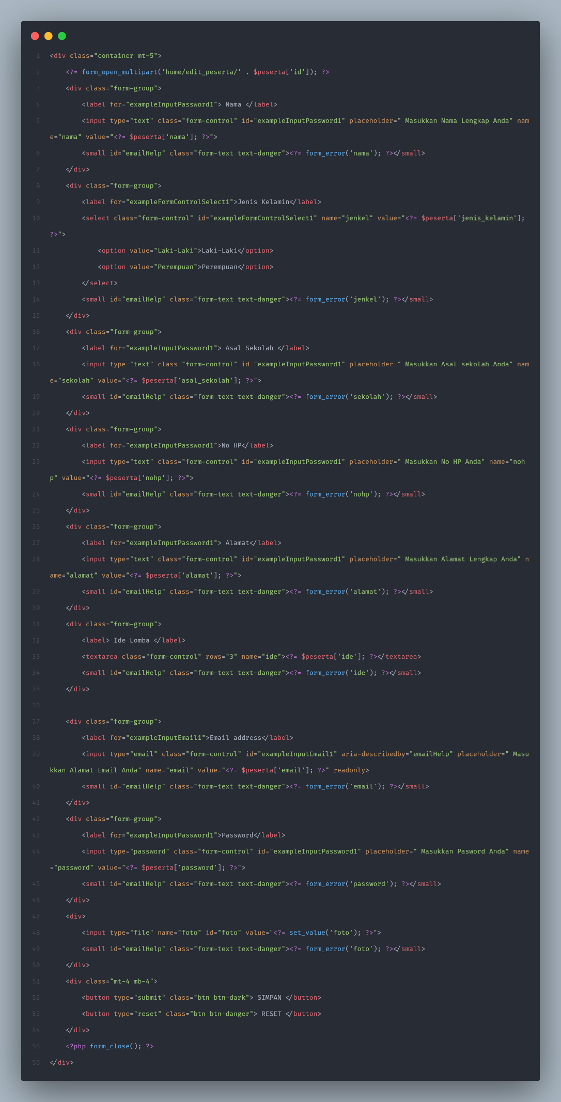

**Kodingan peserta delete**

